

Faculty of Nursing
Medical-Surgical Nursing II Course
Surgical Rotation
2022/2023

Anorectal Disorders

Prepared by:
Dr. Asmaa Abdel Hafez
Dr. Yasser Mahmoud
Revision note: Original wording was retained where accurate. Revised, expanded, or newly added content in this edition is shown in bold blue text for peer-review visibility.

1

- Outline:

- Introduction
- Applied anatomy and physiology of the anal canal
- Epidemiology and common risk factors
- Major anorectal disorders:
  - Anorectal abscess
  - Anal fistula
  - Anal fissure
  - Hemorrhoids
- Pathophysiology and classification
- Clinical manifestations and assessment
- Potential complications
- Conservative, office-based, and surgical management
- Nursing care across the continuum of care
- Patient and family health education
- Common nursing diagnoses and goals of care

Introduction
Anorectal disorders are common conditions affecting the anal canal, perianal tissues, and distal rectum. Patients commonly present with pain, bleeding, swelling, discharge, pruritus, prolapse, or altered bowel habits. Because these symptoms may also occur in colorectal malignancy, inflammatory bowel disease, or infection, careful assessment is essential.
Hemorrhoids, anal fissures, anorectal abscesses, and anal fistulas are among the most frequent disorders encountered in medical-surgical practice. For nurses, early recognition of red-flag symptoms, pain control, bowel regulation, hygiene education, and postoperative monitoring are central responsibilities.

Anatomy and physiology of the anal canal
- The anal canal is the terminal 3 to 4 cm of the gastrointestinal tract, extending from the anorectal junction to the anal verge. The dentate line is an important landmark because it separates different epithelium, blood supply, lymphatic drainage, and sensory innervation.
- Continence depends on coordinated function of the internal anal sphincter, external anal sphincter, puborectalis muscle, vascular cushions, rectal compliance, and intact neurologic control.
- Arterial supply is derived mainly from the superior, middle, and inferior rectal arteries. Venous drainage occurs through the superior rectal vein to the portal system and through the middle and inferior rectal veins to the systemic circulation.
- Above the dentate line, sensation is visceral and relatively insensitive to pain. Below the dentate line, somatic innervation from the inferior rectal branches of the pudendal nerve makes the area highly sensitive to pain, touch, and temperature.
- Anal sphincters:
- Internal anal sphincter: a continuation of the circular smooth muscle of the rectum; it is involuntary and provides most resting anal tone.

Spasm or hypertonicity of the internal sphincter contributes to pain and impaired healing in many chronic anal fissures. The longitudinal muscle layer lies between the sphincters and contributes to support of the anal canal.
- External anal sphincter: a striated voluntary muscle under somatic control; together with the puborectalis muscle, it helps maintain continence during increased intra-abdominal pressure.
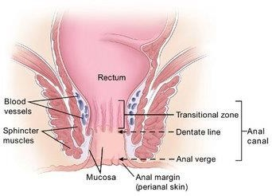

Common anorectal disorders
- Anorectal abscess
- Anal fistula
- Anal fissure
- Hemorrhoids

Anorectal abscess
An anorectal abscess is a localized collection of pus arising most often from infection of the anal glands (cryptoglandular infection). It is usually acute, painful, and may be superficial or deep.

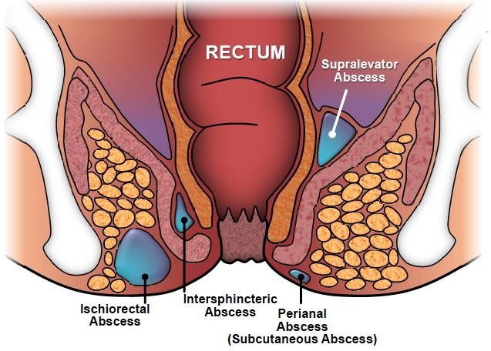

Pathophysiology
Most anorectal abscesses begin when an anal gland becomes obstructed and infected within the intersphincteric space.
The infection may track into the perianal, ischiorectal, intersphincteric, or supralevator spaces, depending on the path of least resistance.
Mixed aerobic and anaerobic intestinal flora are commonly involved; culture is usually reserved for atypical, recurrent, or immunocompromised cases.
If the abscess drains spontaneously or is incompletely treated, a persistent epithelialized tract may develop and later present as an anal fistula.
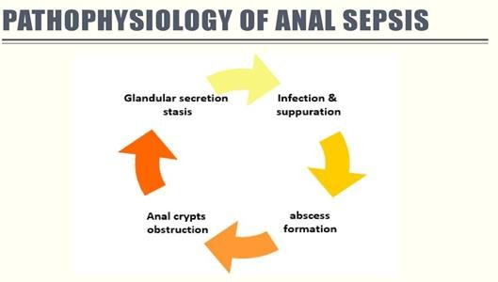

Risk factors
Important risk factors include Crohn's disease, diabetes mellitus, immunosuppression, local trauma, prior anorectal infection, tuberculosis or other atypical infection, and conditions associated with poor wound healing.

Clinical features
- Severe, constant throbbing anal or perianal pain that worsens with sitting, walking, coughing, or defecation.
- Localized erythema, swelling, tenderness, warmth, or a fluctuant mass; deep abscesses may have less obvious external findings.
- Purulent drainage or perianal soilage if spontaneous rupture occurs.
- Fever, malaise, tachycardia, or sepsis may occur, especially in deep, delayed, or immunocompromised presentations.

Complications
  - Fistula-in-ano.
  - Local extension with recurrent or persistent sepsis.
  - Rarely, necrotizing soft-tissue infection or systemic sepsis.
  - Delayed healing, especially in patients with diabetes, Crohn's disease, or immunosuppression.

Management
- Diagnosis is based primarily on history and anorectal examination; digital rectal examination may be limited by pain, and imaging is reserved for deep, recurrent, or complex disease.
- Prompt incision and drainage is the definitive treatment. Antibiotics are not required routinely after uncomplicated drainage but are indicated when cellulitis, systemic infection, immunosuppression, valvular heart disease, or extensive tissue involvement is present.
- Drainage may be performed under local anesthesia for a superficial abscess, whereas deep or complex abscesses usually require examination under anesthesia in the operating room.
- Patients need follow-up because a fistula may already be present or may develop during healing.

Nursing care
- Assess pain, temperature, wound drainage, and surrounding skin; report increasing pain, fever, foul odor, or new bleeding promptly.
- Provide prescribed analgesia, encourage warm sitz baths after the acute drainage period, and support gentle cleansing and careful drying of the perianal area.
- Promote soft stools with adequate fluids, fiber, and stool softeners as prescribed, and reinforce the importance of follow-up for recurrent drainage or fistula formation.

Anal fistula
An anal fistula is an abnormal tract connecting the anal canal or rectum to the perianal skin. Most arise after a cryptoglandular abscess, although Crohn's disease, trauma, malignancy, radiation, and obstetric or surgical injury are also possible causes.

Risk factors
- Previous anorectal abscess.
- Crohn's disease or chronic anorectal inflammation.
- Trauma, surgery, radiation, or obstetric injury.
- Tuberculosis, malignancy, or other less common secondary causes.

Clinical features
- Persistent or intermittent purulent drainage, perianal irritation, recurrent swelling or pain, and a visible external opening; some patients report passage of flatus or stool through an abnormal tract in complex fistulas.

Complications
- Recurrent infection or abscess formation.
- Impaired continence when the sphincter complex is involved or repeatedly injured.
- Recurrence after treatment, especially in complex fistulas or Crohn's disease.

Management
- Assessment includes inspection, gentle digital rectal examination when tolerated, anoscopy, and imaging such as MRI or endoanal ultrasonography for complex or recurrent fistulas.

- Medical therapy alone does not usually cure a cryptoglandular fistula; antibiotics may be used temporarily for associated infection, and biologic therapy may be needed for Crohn's-related fistulas.
- Surgical options are selected according to fistula anatomy and continence risk and may include fistulotomy, seton placement, advancement flap, or ligation of the intersphincteric fistula tract (LIFT).

Nursing care
- Observe the amount, color, odor, and frequency of drainage and assess the surrounding skin for maceration.
- Teach meticulous perianal hygiene, regular dressing changes if prescribed, and the use of absorbent pads when needed.
- Encourage loose, breathable clothing and careful drying of the area after bathing.
- Warm sitz baths may reduce discomfort and improve local cleanliness.
- If packing or a drain is used, follow the surgical order exactly and teach the patient not to remove devices unless instructed.
- Reduce straining by promoting regular bowel habits and treating constipation early.
- Encourage adequate fluid intake and a fiber-rich diet unless contraindicated.
- Explain the importance of follow-up because delayed healing or recurrent drainage may indicate persistent fistula activity.

Anal fissure
An anal fissure is a linear tear in the anoderm, usually distal to the dentate line. Most fissures occur in the posterior midline; lateral or multiple fissures warrant evaluation for secondary causes such as Crohn's disease, tuberculosis, HIV infection, trauma, or malignancy.
Acute fissures are generally present for less than 6 weeks. Chronic fissures persist beyond 6 weeks and may be associated with a sentinel skin tag, hypertrophied anal papilla, or exposed internal sphincter fibers.
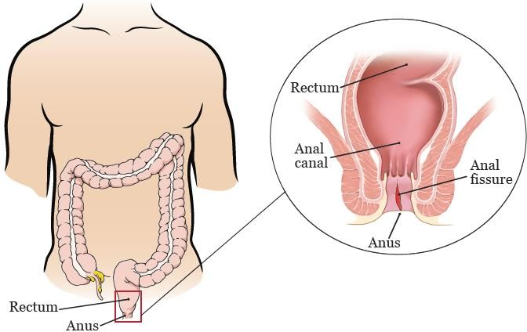

Risk factors
- Passage of hard stool or chronic constipation.
- Repeated diarrhea or local irritation.
- Inflammatory bowel disease or other secondary anorectal disease.
- Childbirth or traumatic anal instrumentation.
- Dehydration, low-fiber diet, or prolonged straining.
- Persistent internal sphincter spasm, which reduces local blood flow and delays healing.

Clinical features
- Severe sharp pain during and after defecation; this is the most common presenting symptom.
- Small amounts of bright red bleeding on toilet tissue or on the surface of stool.
- Anal spasm, fear of defecation, and pruritus or irritation in some patients.

Complications
Transition to a chronic fissure with recurrent pain and bleeding.
- Secondary infection or local inflammation, although frank abscess is uncommon.
- Constipation caused by avoidance of painful defecation.
- Reduced quality of life due to persistent pain and anxiety related to bowel elimination.

Management
- Diagnosis is usually made by careful inspection. Forceful digital rectal examination is avoided in severe pain because it may worsen spasm and distress.

Conservative and medical management:
- Increase dietary fiber, fluid intake, and bowel regularity; stool softeners or bulk-forming agents are often used to prevent further tearing.
- Warm sitz baths and simple analgesia help reduce pain and internal sphincter spasm.
- Topical local anesthetic may provide short-term relief, but it does not treat the underlying sphincter hypertonicity.
- For chronic fissure, topical calcium channel blockers (such as diltiazem or nifedipine) or topical glyceryl trinitrate may promote healing by relaxing the internal sphincter and improving blood flow.

- Botulinum toxin injection is an additional option in selected patients when topical therapy fails or is not tolerated.

Surgical management:
Surgery is considered for chronic or refractory fissures after adequate medical therapy.
Lateral internal sphincterotomy has high healing rates but must be weighed against the risk of incontinence, particularly in high-risk patients.

Nursing care
- Assess pain severity, bowel pattern, hydration status, and anxiety about defecation.
- Teach the patient to avoid straining, delay of defecation, and excessive wiping.
- Support high-fiber food choices, adequate oral fluids, and prescribed stool-softening therapy.
- Encourage warm sitz baths after bowel movements and as needed for sphincter relaxation.
- Administer topical medications exactly as prescribed and teach correct application technique.
- Monitor for persistent bleeding, worsening pain, or atypical fissure features that require re-evaluation.
- Reinforce follow-up for nonhealing fissures or recurrent symptoms.
- Provide reassurance that consistent bowel management is essential to break the pain-spasm-constipation cycle.

Hemorrhoids
Hemorrhoids are symptomatic enlargement and distal displacement of the normal anal vascular cushions. These cushions contribute to fine continence; disease develops when supporting tissue deteriorates and venous congestion or prolapse occurs.

Classification
Internal hemorrhoids arise above the dentate line and are classified by degree of prolapse.
External hemorrhoids arise below the dentate line and may cause acute pain when thrombosed; the Goligher grades apply to internal hemorrhoids, not external hemorrhoids.

Classification | Description
Grade I | Bleeding without prolapse.
Grade II | Prolapse with spontaneous reduction.
Grade III | Prolapse requiring manual reduction.
Grade IV | Irreducible prolapse, which may be incarcerated or strangulated.

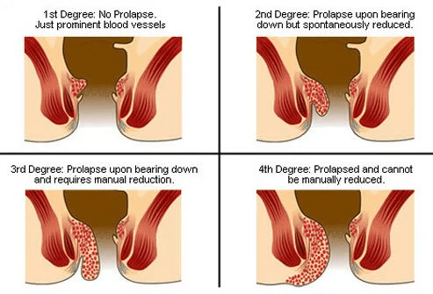

Risk factors
- Chronic constipation, straining, and prolonged sitting on the toilet.
- Pregnancy, increasing age, low-fiber diet, and reduced physical activity.
- Raised intra-abdominal pressure, chronic cough, obesity, or heavy lifting.
- Portal hypertension is not a cause of hemorrhoids, but coexisting anorectal disease and family history may influence symptoms and care seeking.

Clinical features
- Painless bright red rectal bleeding, usually seen on toilet tissue or coating the stool rather than mixed within it.
- Pruritus, mucus soiling, or a feeling of incomplete cleanliness.
- Prolapse, rectal fullness, or a palpable anal lump.
- Thrombosed external hemorrhoids cause sudden severe anal pain and tense perianal swelling.

Complications
- Iron deficiency anemia from chronic bleeding is uncommon but possible.
- Thrombosis, ulceration, or strangulation of prolapsed tissue.
- Persistent prolapse with hygiene difficulties or mucus leakage.
- Pain, edema, or secondary inflammation following untreated or advanced disease.

Conservative and office-based management
Diagnosis is based on history, inspection, digital rectal examination when appropriate, and anoscopy; endoscopic evaluation may be required when bleeding is unexplained or red-flag features are present.
Conservative management is first line for most patients and includes increased fiber intake, adequate fluids, avoidance of straining, regular exercise, and limiting prolonged toilet sitting.
- Rubber band ligation is the preferred office procedure for most symptomatic grade I to II and selected grade III internal hemorrhoids.
- Infrared coagulation or sclerotherapy may be used for selected small bleeding internal hemorrhoids.
- Topical agents may provide temporary symptom relief, but they do not correct significant prolapse.
- Acutely thrombosed external hemorrhoids may be managed conservatively or excised early in carefully selected patients.

Surgical management
- Excisional hemorrhoidectomy is usually reserved for large external hemorrhoids, combined internal and external hemorrhoids, or persistent grade III to IV disease.
- Stapled hemorrhoidopexy or Doppler-guided procedures may be considered in selected patients, but recurrence patterns differ and local expertise is important.
- Post-procedure pain control, bleeding surveillance, and bowel regulation are essential after any hemorrhoid intervention.

Nursing care
- Promote gentle perianal hygiene and careful drying after defecation or bathing.
- Teach the patient to avoid straining, heavy lifting during acute symptoms, and prolonged sitting on the toilet.
- Encourage a high-fiber diet with fruits, vegetables, and whole grains, together with adequate fluid intake.
- Support regular bowel habits and timely treatment of constipation.
- Warm sitz baths may relieve discomfort; cold packs may be helpful for thrombosed external hemorrhoids if ordered.
- Administer prescribed analgesics, topical agents, or stool softeners and monitor the response.
- Observe for bleeding, urinary retention after surgery, infection, and severe pain that may suggest thrombosis or other complications.
- Reinforce follow-up and instruct the patient to seek care for heavy bleeding, fever, or inability to pass urine or stool.

General education for patients with anorectal conditions
- Patient education is essential for symptom control, recurrence prevention, and safe recovery after anorectal procedures.
- Teach the patient to cleanse the perianal area gently with warm water, then pat dry or use soft unscented wipes; vigorous rubbing should be avoided.
- Explain that bowel regularity is a priority: respond to the urge to defecate promptly and avoid prolonged straining or sitting.
- Demonstrate safe sitz-bath use, including water temperature testing, duration, and frequency according to symptoms or postoperative instructions.
- After anorectal surgery, pain and sphincter spasm are common during the first 24 to 48 hours; prescribed analgesia and nonpharmacologic comfort measures should be used consistently.
- Cold therapy may reduce early swelling, whereas warm compresses or sitz baths are usually more helpful after the immediate postoperative period to improve comfort and local circulation.
- Encourage adequate fluid intake, fiber, ambulation, and prescribed stool softeners to prevent constipation and painful defecation.
- Teach the correct use of topical medications and warn against prolonged unsupervised use of steroid-containing preparations.

- Review warning signs that require urgent reassessment: fever, increasing pain, purulent drainage, heavy rectal bleeding, urinary retention, fecal incontinence, or inability to pass stool or gas.
- Promote adherence by addressing embarrassment, pain, and anxiety, and by giving simple written instructions for home care.
If dressings or compresses are ordered, they should be changed using clean technique and the surrounding skin should be protected from maceration.
- Barrier ointments may be used when drainage is frequent to protect surrounding skin, according to the treatment plan.
- Positioning for comfort, adequate rest, and scheduled follow-up appointments should be emphasized during discharge teaching.

Common nursing diagnoses with anorectal disorders

Constipation related to fear of painful defecation, inadequate fiber or fluid intake, and voluntary suppression of the urge to defecate
Possible evidence includes infrequent bowel movements, passage of hard stool, abdominal distention, straining, or a report of rectal fullness.

Goal:
The patient will maintain soft, regular bowel elimination without excessive straining.

Acute pain related to anal inflammation, tissue trauma, sphincter spasm, or prolapsed hemorrhoidal tissue
Possible evidence includes verbal reports of pain, guarding, facial grimacing, reluctance to defecate, or difficulty sitting.

Goal:
The patient will report acceptable pain relief and demonstrate use of prescribed comfort measures.

Impaired comfort related to pain, drainage, itching, swelling, or anxiety about bowel elimination
Possible evidence includes restlessness, irritability, sleep disturbance, reduced activity tolerance, or difficulty performing self-care.

Goal:
The patient will verbalize improved comfort and identify effective strategies to reduce symptoms at home.

Deficient knowledge related to unfamiliarity with the disease process, hygiene measures, medication use, and recurrence prevention
Possible evidence includes incorrect self-care practices, repeated questions, or inability to describe follow-up needs.

Goal:

The patient will explain the treatment plan, warning signs, and home-care measures before discharge.

Additional nursing priorities:
Monitor elimination, hydration, bleeding, wound healing, and signs of infection or impaired continence.
Individualize nursing diagnoses according to the specific disorder, procedure performed, comorbidities, and patient learning needs.

Selected current references
American Society of Colon and Rectal Surgeons (ASCRS). Clinical Practice Guideline: Management of Hemorrhoids, 2024.
American Society of Colon and Rectal Surgeons (ASCRS). Clinical Practice Guideline: Management of Anal Fissures, 2023.
American Society of Colon and Rectal Surgeons (ASCRS). Clinical Practice Guideline: Management of Anorectal Abscess, Fistula-in-Ano, and Rectovaginal Fistula, 2022.
BMJ Best Practice topic reviews on hemorrhoids, anal fissure, and anorectal abscess/fistula for current supportive nursing and medical management principles.

